Experiment no:9

Date:

Experiment title : Dataflow diagram for hospital management system

Aim
The aim of this experiment is to design and analyze a system by applying structured methodologies, focusing on understanding the problem, planning the solution, and evaluating feasibility to produce an effective and meaningful outcome.

Problem Description
The problem involves developing a structured representation of a system (such as a Data Flow Diagram for a Hospital Management System). The objective is to clearly define how data flows between different entities, processes, and data stores within the system.

Given Conditions / Constraints
- The system should be simple and easy to understand.
- Only essential entities and processes should be included.
- Standard design rules must be followed.
- Time constraints must be considered while completing the design.
- The model should reflect real-world scenarios accurately.

Approach / Methodology
- Identify system requirements and key entities.
- Classify inputs, processes, and outputs.
- Use structured design techniques like DFD.
- Develop the model step-by-step (Level 0 or higher levels if required).
- Verify correctness and completeness of the design.

Planning and Estimation
- Divide the work into stages:
  - Requirement analysis
  - Design preparation
  - Diagram construction
  - Review and correction
- Estimate time required for each stage.
- Allocate sufficient time for understanding and verification.

Scheduling / Design Considerations
- Follow a sequential approach while designing.
- Maintain clarity and avoid unnecessary complexity.
- Ensure proper labeling of all components.
- Use standard symbols and notation.
- Complete each stage within the allocated time.
Diagram:
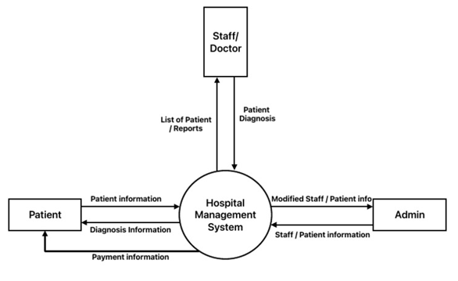

Feasibility Analysis
- Technical Feasibility: Design can be implemented using standard tools and techniques.
- Economic Feasibility: No additional cost is required (conceptual design).
- Operational Feasibility: System is practical and reflects real-world usage.
- Schedule Feasibility: Can be completed within the given time frame.
Observation:
It is observed that DFD clearly represents how the dataflows between Staff/Doctor,patient Admin within the system.

Result:
The system model (DFD) was successfully designed, showing clear data flow between entities, processes, and data stores. The design meets all specified requirements and constraints.

Conclusion
The experiment demonstrates that structured design methods help in creating clear and efficient system models. Proper planning, analysis, and feasibility evaluation are essential for successful system development

